## Assignment A - Regular Languages 1

*These items are primarily to enable and encourage you to work directly with representations of regular languages in preparation for future work and upcoming exams. Use of JFLAP allows you to check the correctness of your work, enables exploration of operational behaviors of the formalisms, and provides a consistent means for sharing and assessment.*

*The intended and recommended approach is as follows:*

1. Attempt each of the primary activities without reference to others' solutions or use of an automated computational tool (such as JFLAP).
2. Develop a solution and a set of data that helps validate the solution.
3. After you have deemed a solution satisfactory, implement that solution in JFLAP and use JFLAP's features to analyze and test your work.
4. Clean up or annotate your solution as necessary for submission.

*This approach best prepares you for success on exams and putting this knowledge into practice.*

A1. Design a DFA for each of the following languages under the alphabet Σ = {0, 1}.

* a1dfa1.jff = { w | 00 is not a substring of w }
* a1dfa2.jff = { w | neither 00 nor 000 is a substring of w }
* a1dfa3.jff = { w | neither 00 nor 010 is a substring of w }
* a1dfa4.jff = { w | neither 00 nor 0100 is a substring of w }
* a1dfa5.jff = { w | neither 000 nor 001 is a substring of w }

Implement each in JFLAP and upload the five corresponding JFLAP files using the specified filenames (a1dfa1.jff, a1dfa2.jff, etc.).

Consider whether any of these languages are equivalent and separate these languages into groups (sets) that accept the same language.

Use Online Text to indicate the groupings as equivalence sets; for example:  
{11a.jff, 11c.jff} {11b.jff} {11d.jff, 11e.jff}

Reflect on the experience of constructing these DFAs.

Use Online Text to report observations related to your learning.

A2. Convert the following NFA into a DFA.

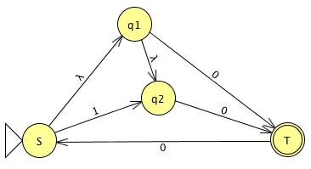

Implement the DFA using JFLAP and upload the DFA as a file named a2dfa.jff

Reflect. Use Online Text to report observations related to your learning.

A3. Finite automata are useful components of computers and algorithms, thus it is important to be able to minimize the number of states of a given DFA. Convert the following DFA to a minimum-state equivalent DFA.

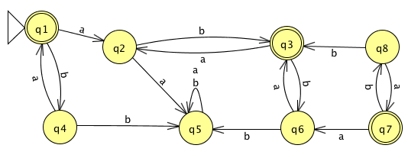

Implement the minimized DFA using JFLAP and upload that DFA as a file named a3mindfa.jff

Reflect. Use Online Text to report observations related to your learning.

A4. Consider the following regular grammar with start symbol S and terminals {x, y}.

S→ xS  
S→ yX  
S→ yY  
X→ xX  
X→ yS  
Y→ xY  
Y→λ

Using Online Text...  
A4a. List four strings, each of length less than 4, accepted by this grammar. (Include ε if it is accepted.)

A4b. List four strings, each of length less than 4, not accepted by this grammar. (Include ε if it is not accepted.)

A4c. In English, describe the language represented by this grammar.

Reflect. Use Online Text to report observations related to your learning.

A5. Define a right-linear grammar that generates the following regular language.

The language under the alphabet Σ = {0, 1} comprised of strings in which every 0 must have a 1 adjacent to it on both sides. Examples of strings that are accepted include 101, 1101, 1010101, and 1011101. Examples of rejected strings include 010, 0101, and 1001.

Implement that grammar in JFLAP and upload the implementation as a file named a5rg.jff

Reflect. Use Online Text to report observations related to your learning.